**Node Microservice Architecture**

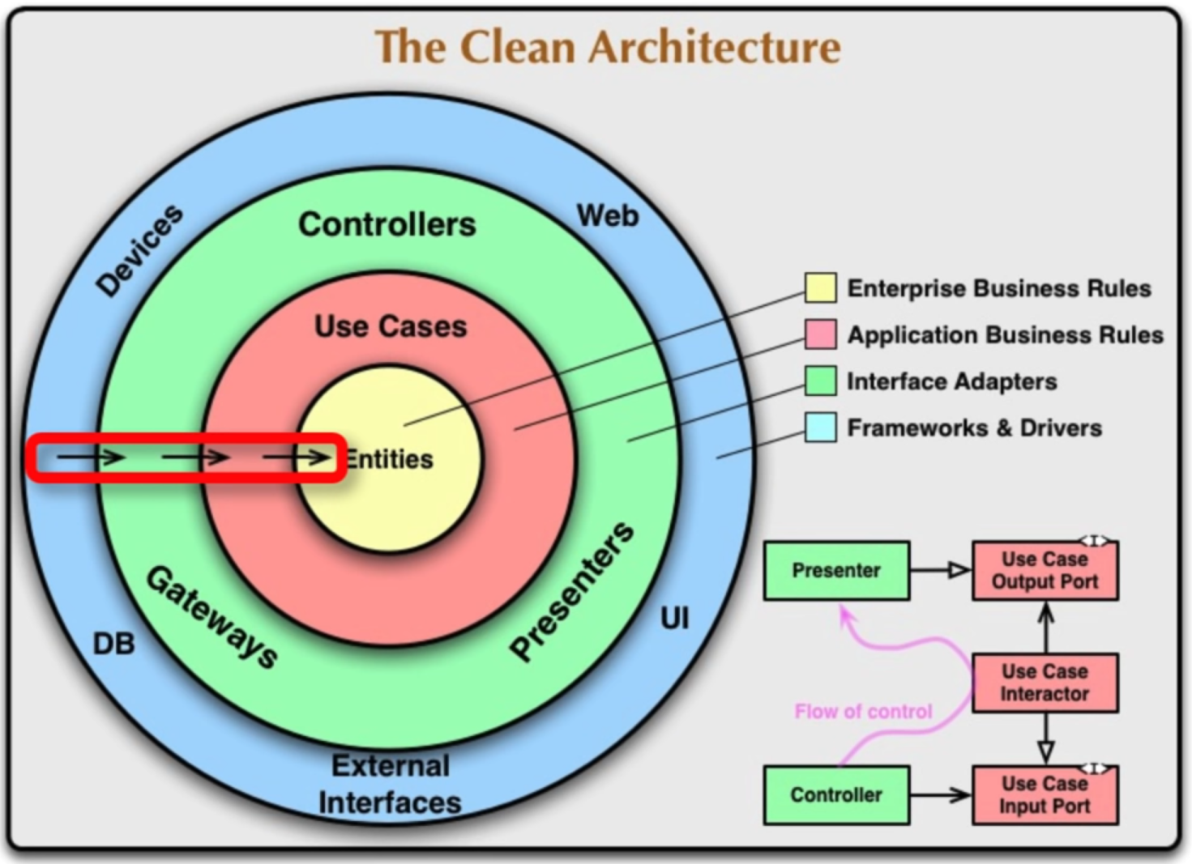

**Entity**

No import / require – no dependencies

Only dependency injection i.e receive all dependencies as a function parameter

Have all validations for mandatory properties

Inculde object.freeze() – to have the object properties changed only during creation of object and not later on, Generate getters to get value in freeze(),

If change in object property is needed create setter methods in the freeze() to expose

**Example entity structure**

<https://github.com/dev-mastery/comments-api/blob/master/src/comment/comment.js>

**Entity Wrapper**

Like a controller/ has all requires and imports

Wrapper file that instantiates entity by passing imported dependencies

**Reference**

https://github.com/dev-mastery/comments-api